Pohela Boishakh Parade Owl

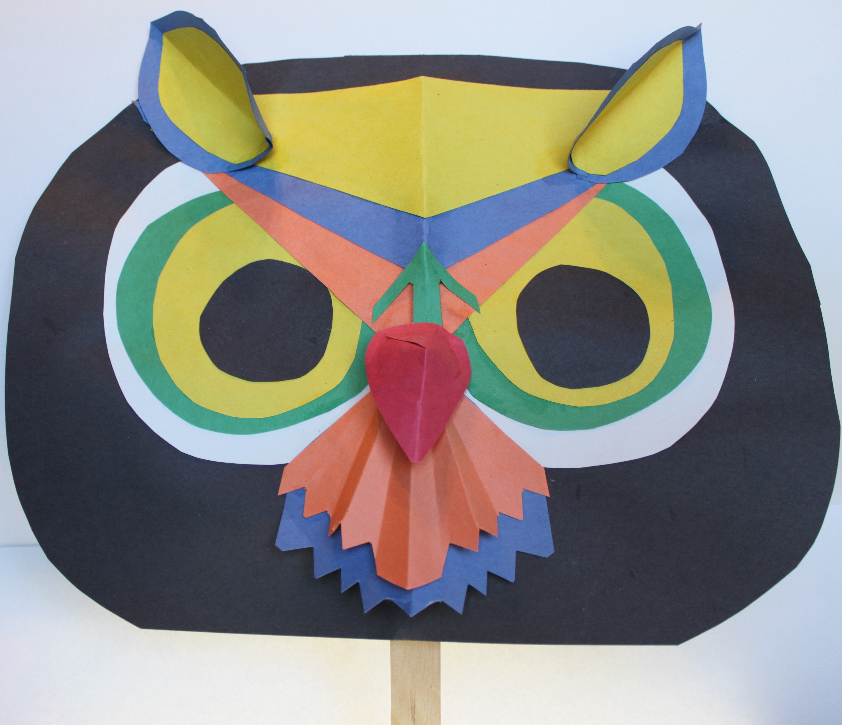

The Pohela Boishakh festival in Bangladesh is a celebration of the Bengali New Year. Every year, in Bengladesh's capital city, Dhaka, the festival takes epic proportions! The day begins at dawn, with readings of Rabindranath Tagore's poetry. Later, there is the Mangol Shobhajatra, a parade organised by the Fine Arts students of the Univeristy of Dhaka. The parade is nothing short of spectacular, as the students and faculty create large, colorful works of art featuring a number of folklore related motifs and designs, including giant sculptures of fanciful creatures. Every year, the parade has a special theme. In 2015, the theme had to do with overcoming ignorance and moving boldly into a bright future.

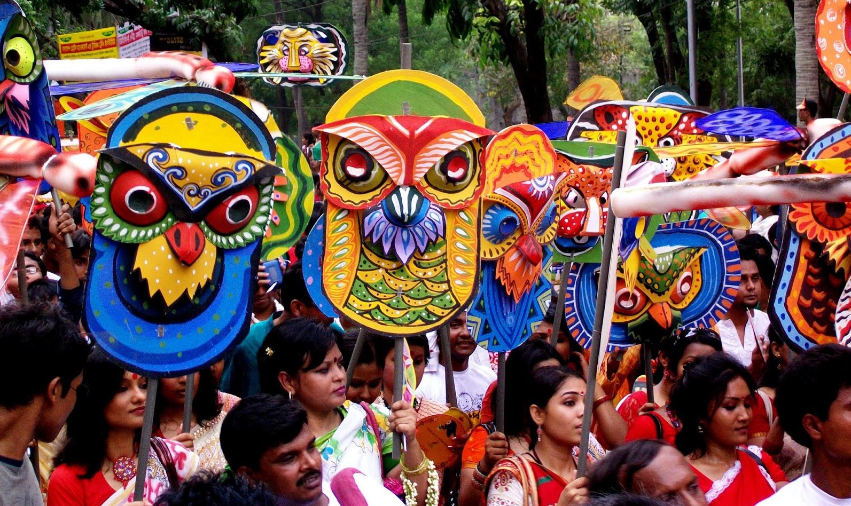

This craft is very relaxed and free-form. The colors can be whatever strikes your fancy, and don’t worry about cutting out perfect shapes or sizes. We are just trying to capture the bright colors, 3-D quality, and portability.

Here’s What you Need to Create the Example:

Construction Paper in Several Colors:
Black-two pieces
Yellow-one piece
Blue-one piece
White-one piece
Green-one piece
Orange-one piece

- Take the black piece of paper and round the edges as shown/
- Take the white paper and cut two circles that are about 3” in diameter.
- Take the green piece of paper and cut two circles that are about 2 ½ “ in diameter.
- Take the yellow paper and cut two circles that are about 2” in diameter.
- Take the black paper and cut two circles that are about 1” in diameter.
- Stack the circles and glue the pieces together to create the owl’s eyes, as show.
- Take the orange paper and fold it in half. Cut a triangle that is approximately 6” long and 3 from the base to the point.
- Take the blue and yellow pieces of paper, and make triangles that are the same length as the orange one, but have graduating depths. Stack the triangles and glue them together, as shown.
- Move the eyes and the large triangles around until you have a pleasing arrangement and then glue them in place.
- Cut a small arrow shape and glue it over the orange and blue triangles, as shown.
- Using the blue paper, cut two small, tear-drop shapes, approximately 1 ½” long and about 1” wide. Then cut two small, yellow teardrops that can fit inside the blue pieces, with a border showing. Glue these pieces together. Fold them in half, lengthwise and glue them to the owl, like “horns” on horned owls. Glue one side down, so that the other side sticks out, creating a 3-D effect.
- Take orange paper and cut a small shape, like a snowcone, approximately 2 ½” – 3” wide and 3” long. Fold it back and forth like a paper fan, and then unfold it again. With the paper folded in half, clip small triangles into the rounded edge.
- Take blue paper and follow the directions in step 12, except the blue “snowcone” should be longer than the orange one.
- Take red paper and cut out a red teardrop shape about 2” long and 2” wide at the fullest point. Then, cut a slit about ½” deep in the round end of the teardrop. Fold one edge under the other, to create a shallow cone shape. Rotate so that the point faces downward, like a beak, and attach to the owl. Loops of tape work best.
- Attach the craft stick to the back of the owl with duct tape.
- Have a Bengali Pohela Baishakh parade!

