Pohela Boishakh Parade
Peacock

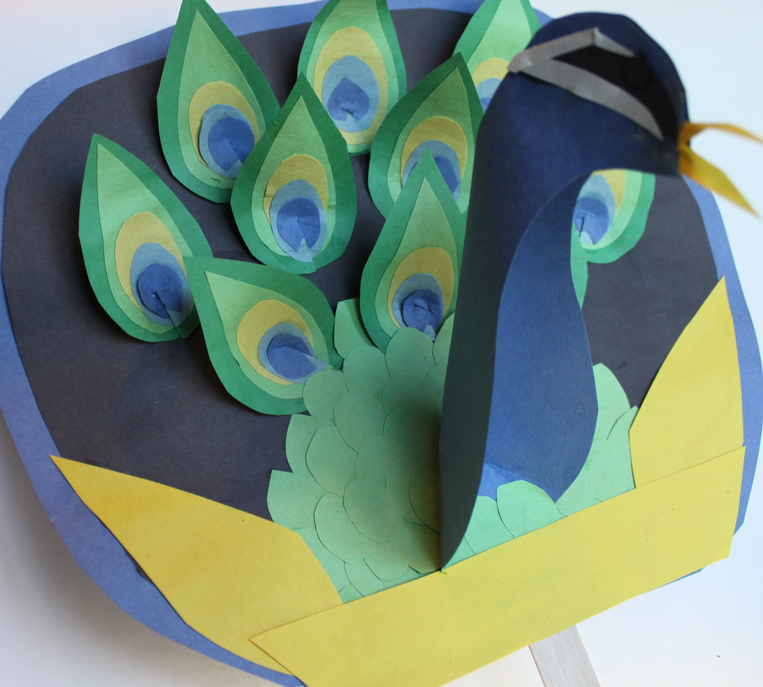

The Pohela Boishakh festival in Bangladesh is acelebration of the Bengali New Year. Every year, in Bengladesh's capital city, Dhaka, the festival takes epic proportions! The day begins at dawn, with readings of Rabindranath Tagore's poetry. Later, there is the Mangol Shobhajatra, a parade organised by the Fine Arts students of the Univeristy of Dhaka. The parade is nothing short of spectacular, as the students and faculty create large, colorful works of art featuring a number of folklore related motifs and designs, including giant sculptures of fanciful creatures. Every year, the parade has a special theme. In 2015, the theme had to do with overcoming ignorance and moving boldly into a bright future.

Here Is What You Will Need:

1. Construction paper in these colors:
black-1 piece
dark blue-2 pieces
light blue-1 piece
dark green-2 pieces
light green-1 piece
yellow-1 piece
white-1 piece
2. Craft stick about one inch wide
3. Scissors
4. Glue (or scotch tape)
5. One piece of duct tape, approximately 3” x 3”

Here’s What to Do:

- Take the dark blue piece of paper and fold in in half, lengthwise. Then cut it into an oval shape, slightly larger at the top than at the bottom. Reserve the scrap paper for later use.
- Then, cut straight across the narrower end of the circle, so that it is flat on the bottom, as shown in the picture.
- Then, take the black piece of paper and cut a similar shape, slightly smaller than the blue one. Glue the black piece onto the blue piece, so that a small blue border can be seen. This is the base of the piece.
- Next, take the second dark blue piece of paper and fold it in half, lengthwise, and cut a shape that looks like this:

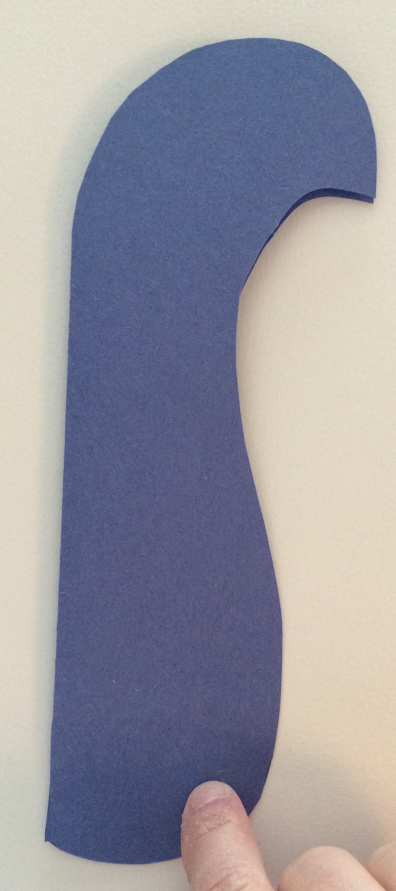

- Open the blue shape and make a shallow cut about 1 to 1 ½ inch deep, as shown:

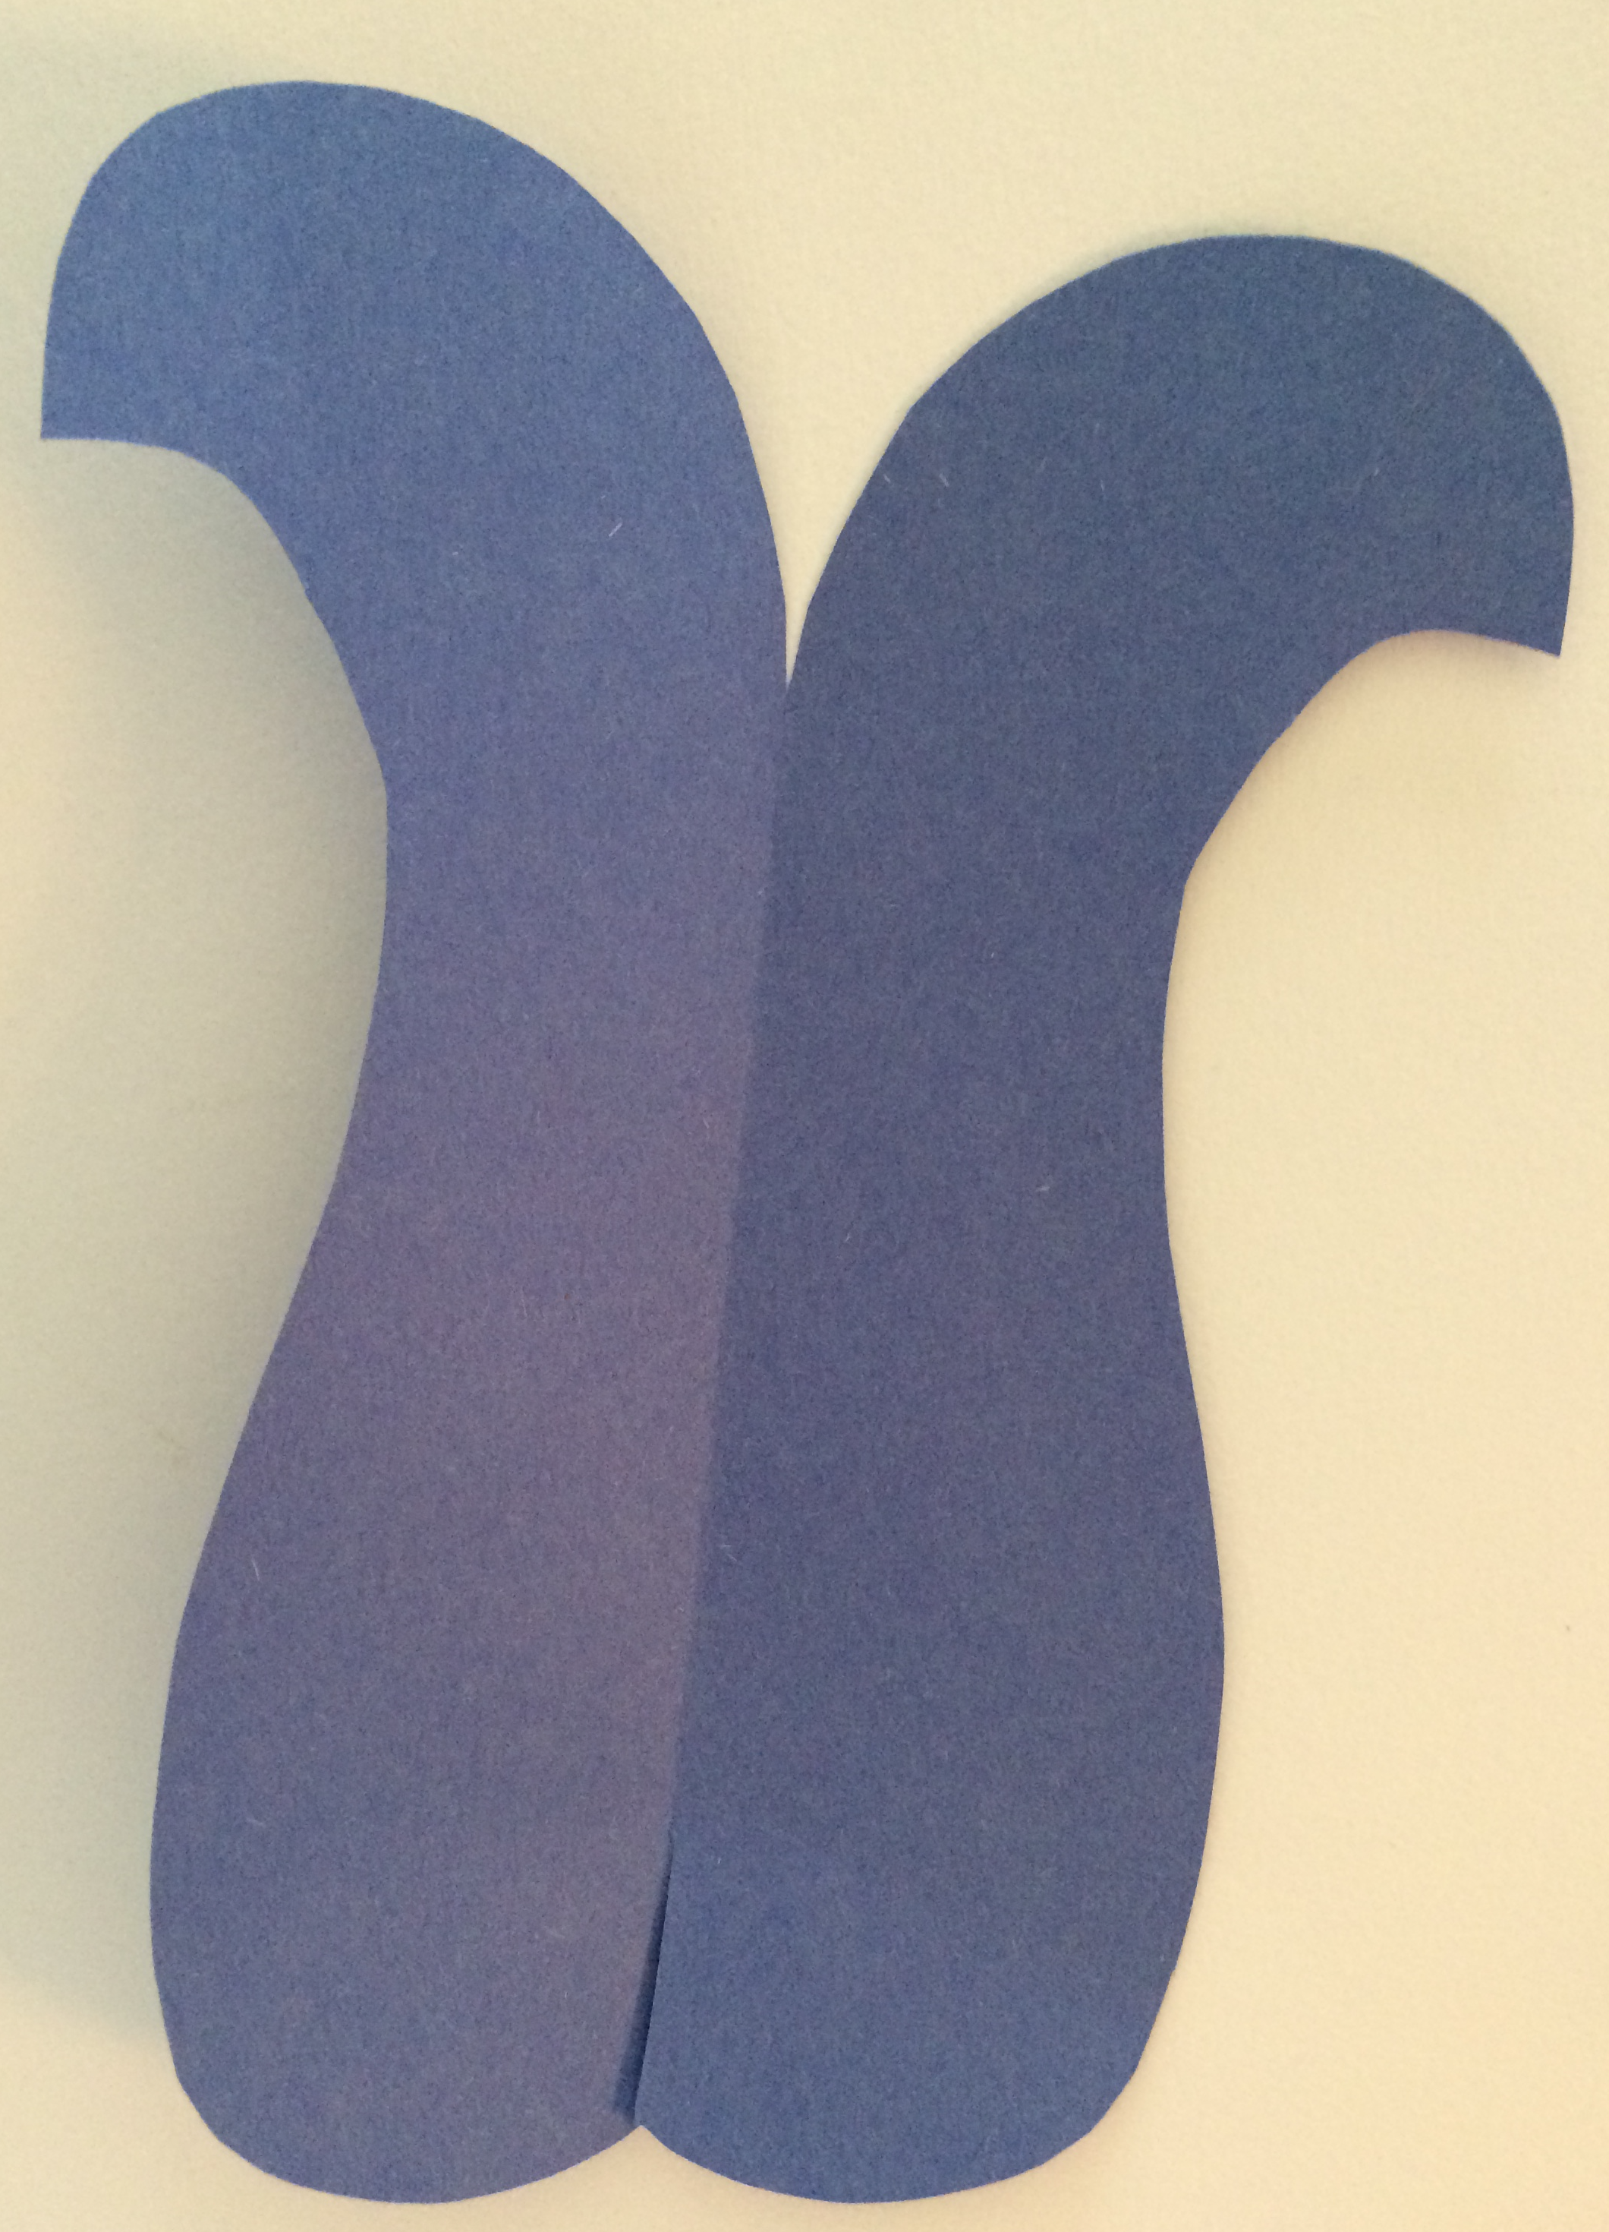

- At the cut line, take one side and fold it under the other, as shown. Secure with glue (or tape).

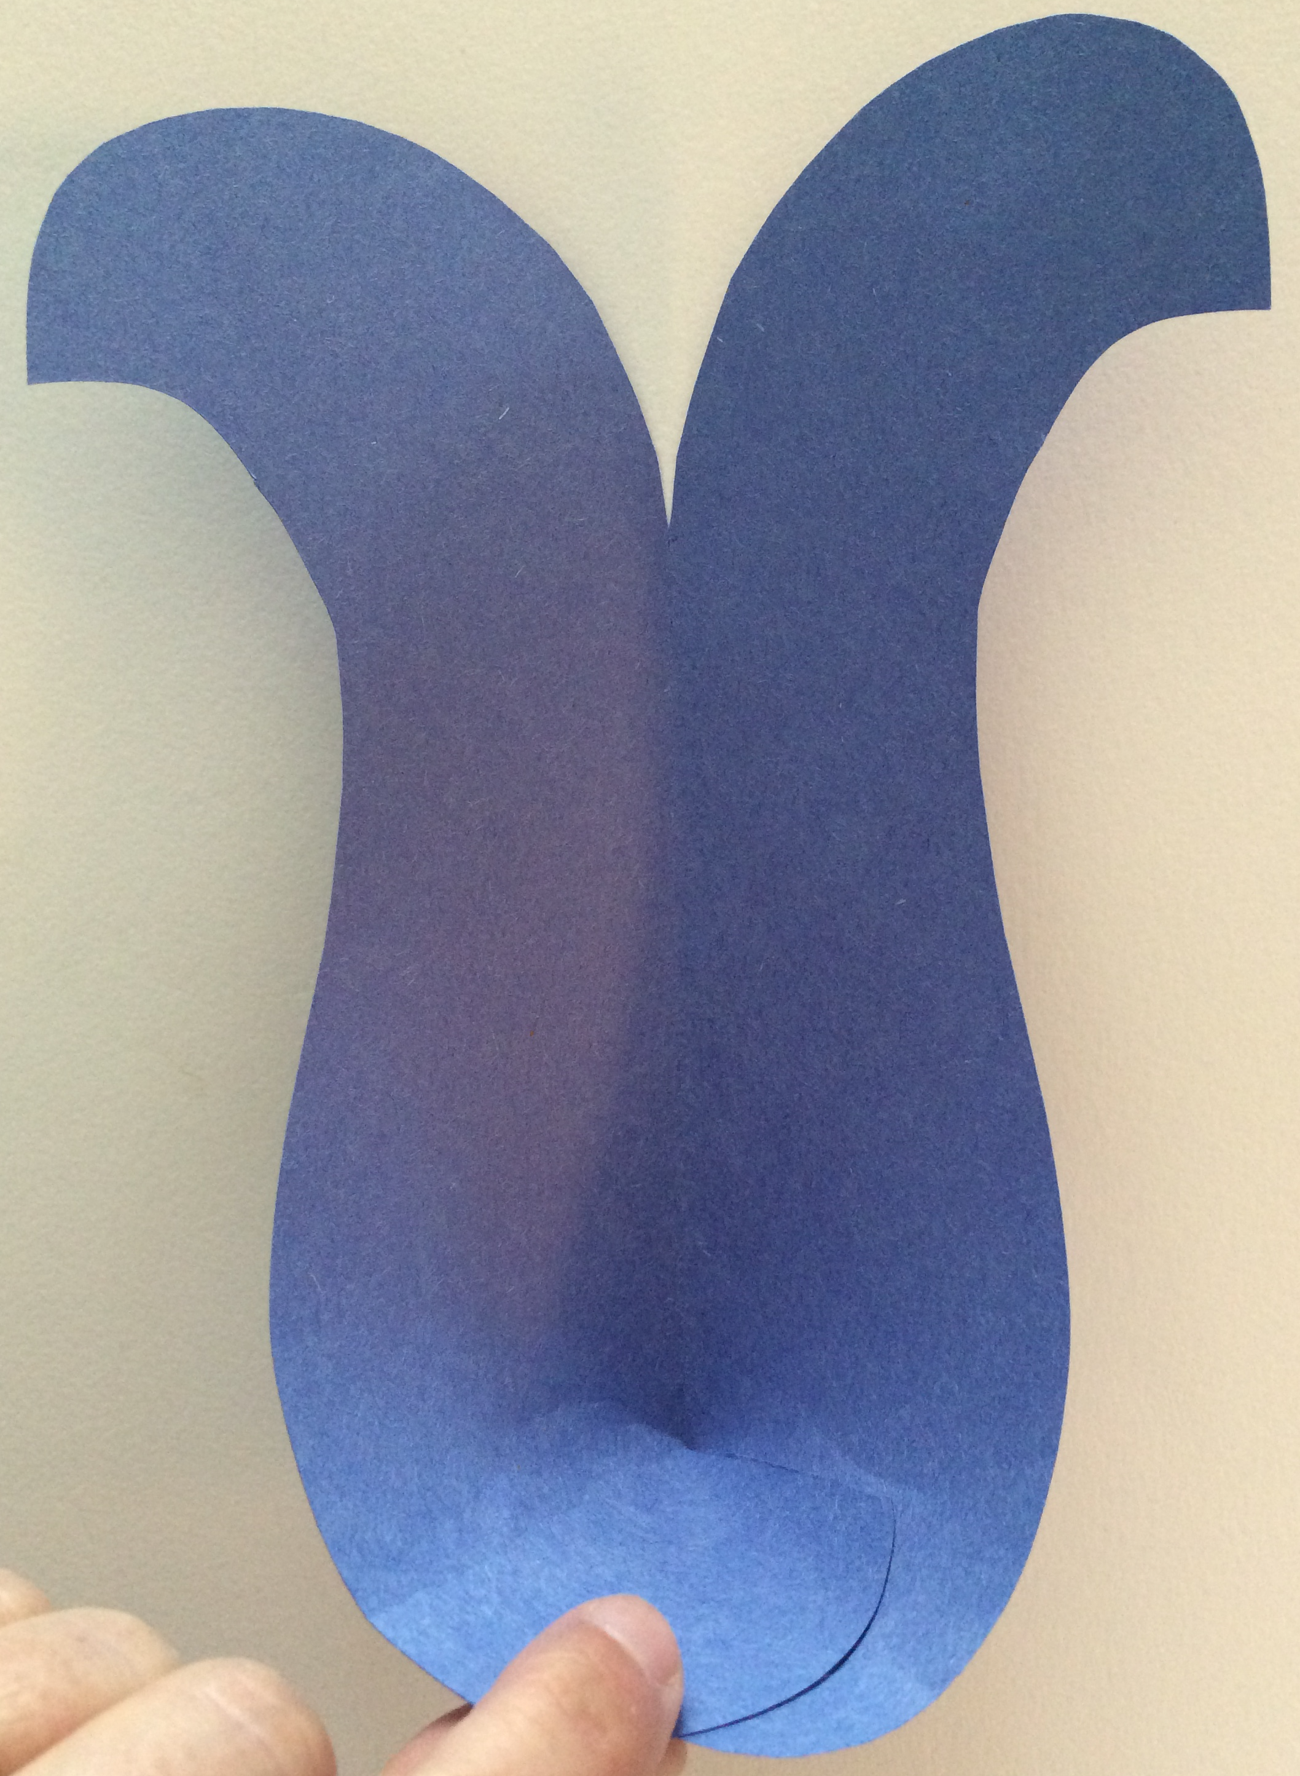

- Glue (or tape) the flat, folded section to the blue and black base, about two inches from the bottom. Make sure this piece is centered.
- Take the yellow piece of paper and cut a thin strip, approximately ½ inch wide and w inches long. Fold the strip in half and then cut a long, narrow, triangle shape. This is the peacock’s beak. Open the beak and glue or tape it inside the head of the peacock, as seen in the photo above. Glue the two sides of the peacock’s head together securely.
- Cut two small crescent moon shapes from the black piece of paper. Glue these on either side of the peacock’s head, where the eyes are located. (refer to picture above.
- Cut two thin strips of white paper and fold and glue them around the black eye pieces. See the white accent strips in the picture above.

Cut the following pieces in graduated sizes, using the photo of the completed project for reference (the project can be simplified by making fewer layers, as desired):
- Take the dark green paper and cut out nine teardrop shapes the same size, approximately 3 inches long and 2 inches wide.
- Take the light green paper and cut 9 teardrop shapes that are slightly smaller than the dark green ones.
- Take the yellow piece of paper and cut out 9 small oval shapes
- Take the light blue paper and cut 9 small oval shapes
- Take scraps of dark blue paper and cut 9 small oval shapes
Assemble the pieces as follows:

- Take the dark green teardrop shapes and make a cut approximately ½ inch long in the base. Fold one side under the other and secure in place. Repeat this process with all of the cut-out shapes.
- When you have all of the pieces assembled, glue them together in layers, as shown in the photo above. You should end up with 9, 3-D “feathers”
- Glue the completed feathers in a pleasing, fan-shaped arrangement.
- Take the light green paper and cut out a number of small ovals. Glue these in place where the neck attaches to the base.
- Cut several strips of yellow paper and arrange them around the base of the piece. These can be any shape that appeals to you. Their purpose is to strengthen the bottom of the project.
- Take a craft stick and glue it to the back of the project with the duct tape.
- When the project dries, enjoy your New Year’s Day Parade!

