Mongolian Horse-head Fiddle
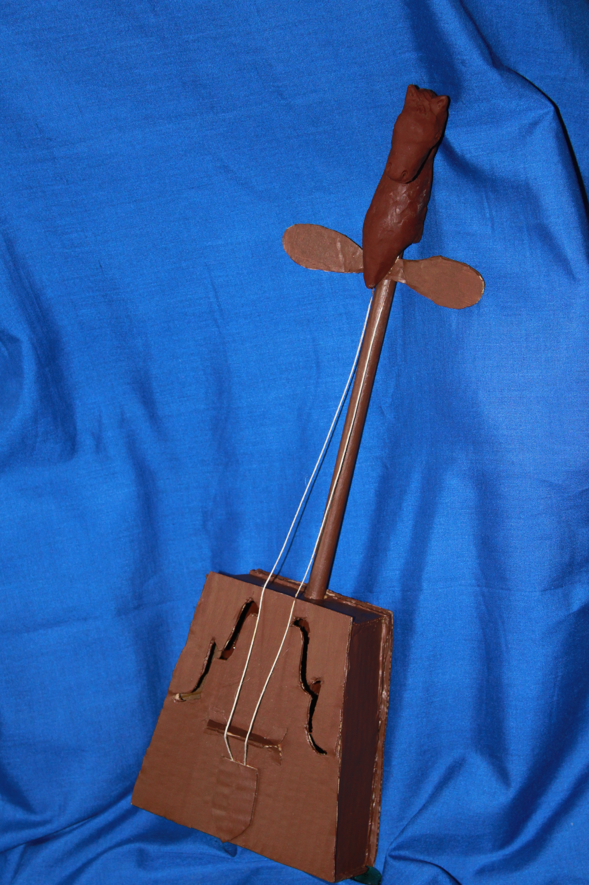
You can make a model of this unique and beautiful instrument. Here’s what you will need:
- Cardboard
- Scrap paper
- Black construction paper
- Brown duct tape
- String
- Dowel rod ½” wide and 24” long.
- Brown polymer clay
- Scissors
- Brown craft paint
- Strong glue
What to Do:
- Take the cardboard and cut two, identical, trapezoid-shaped pieces. They should be approximately 10” high, 6” wide at the base, and 4” wide at the top, but there’s no need to be exact, as long as they are the same.
- Cut out four narrow pieces for the sides and the top of the fiddle. Each should be approximately 2 to 2 ½ inches wide and equal in length of the sides of the trapezoid pieces.
- Take the shortest sidepiece and cut a rounded notch in its base. Make sure the notch is wide enough for the dowel rod to fit through.
Take one of the trapezoid pieces and, using the brown duct tape, securely tape the dowel rod to it, as shown in diagram 2. This piece of cardboard will be the base of the fiddle.

Figure 2

- Place the sides so that they are parallel to the base, with the sides touching.
- Using the duct tape, tape the sides to the base.
- Fold up each side and secure with tape, creating a 5-sided box.
- Squeeze glue onto the top edges of the cardboard sides.
- Place the second trapezoid on top of the fiddle. Let dry.
- After the top is secured, squeeze glue into all of the other seams, especially if tape is showing through the gaps. Press all sides together and let dry.
- While the glue is drying, cut out three additional pieces of cardboard:

1”h x 4”w
Figure 5
2”h x 1”w
Figure 3
Figure 4
1”h x 2”w

- Cut two strings, approx. 18 inches long
- On the scrap paper, draw a scroll-like shape similar to the one shown in diagram 6. When you have a shape you like, cut it out and set it aside.
f

Figure 6

- When the glue is completely dry, paint the entire fiddle with the brown craft paint. Let dry.
- While the paint dries, open your package of polymer clay and knead it until it is soft. Then sculpt a horse’s head, neck, and chest. The horse can be realistic or fanciful. Just make sure that the neck and chest are large enough to accommodate the dowel.
- When you have finished your sculpture, push the head and neck onto the end of the dowel. Do this carefully, so you don’t ruin your sculpture.
- Very carefully, remove the sculpture.
- Harden the clay due as directed on the package. Make sure you have adult supervision.
- While the clay bakes and cools, use a small amount of glue or very thin strips of duct tape to secure the two strings and figure 3 near the top of the dowel rod. These will be the tuning pegs for your fiddle.
- Take the 5-sided piece and bend it as shown in figure 7.
Fold

Figure 7

- Glue the base of the 5-sided shape to the fiddle, so that the trapezoid shape stands out. This is the bridge for the strings.
- Pull the two strings downward over the bridge and glue
them beneath figure 4. This will be the tail piece for your model instrument.
- When the horse-head is cool, put some glue into the opening at the horse’s
shoulder and slide it onto the dowel rod, covering the tops of the strings and the cardboard tuning pegs.
24. Using a white colored pencil, trace your f onto the piece of black paper.
Then, turn the shape over and trace out a mirror image. Cut both shapes out and
glue them to the top of the fiddle box, on either side of the strings.
Enjoy Your Model Horse-head Fiddle!

