Mongolian Boy’s Hat
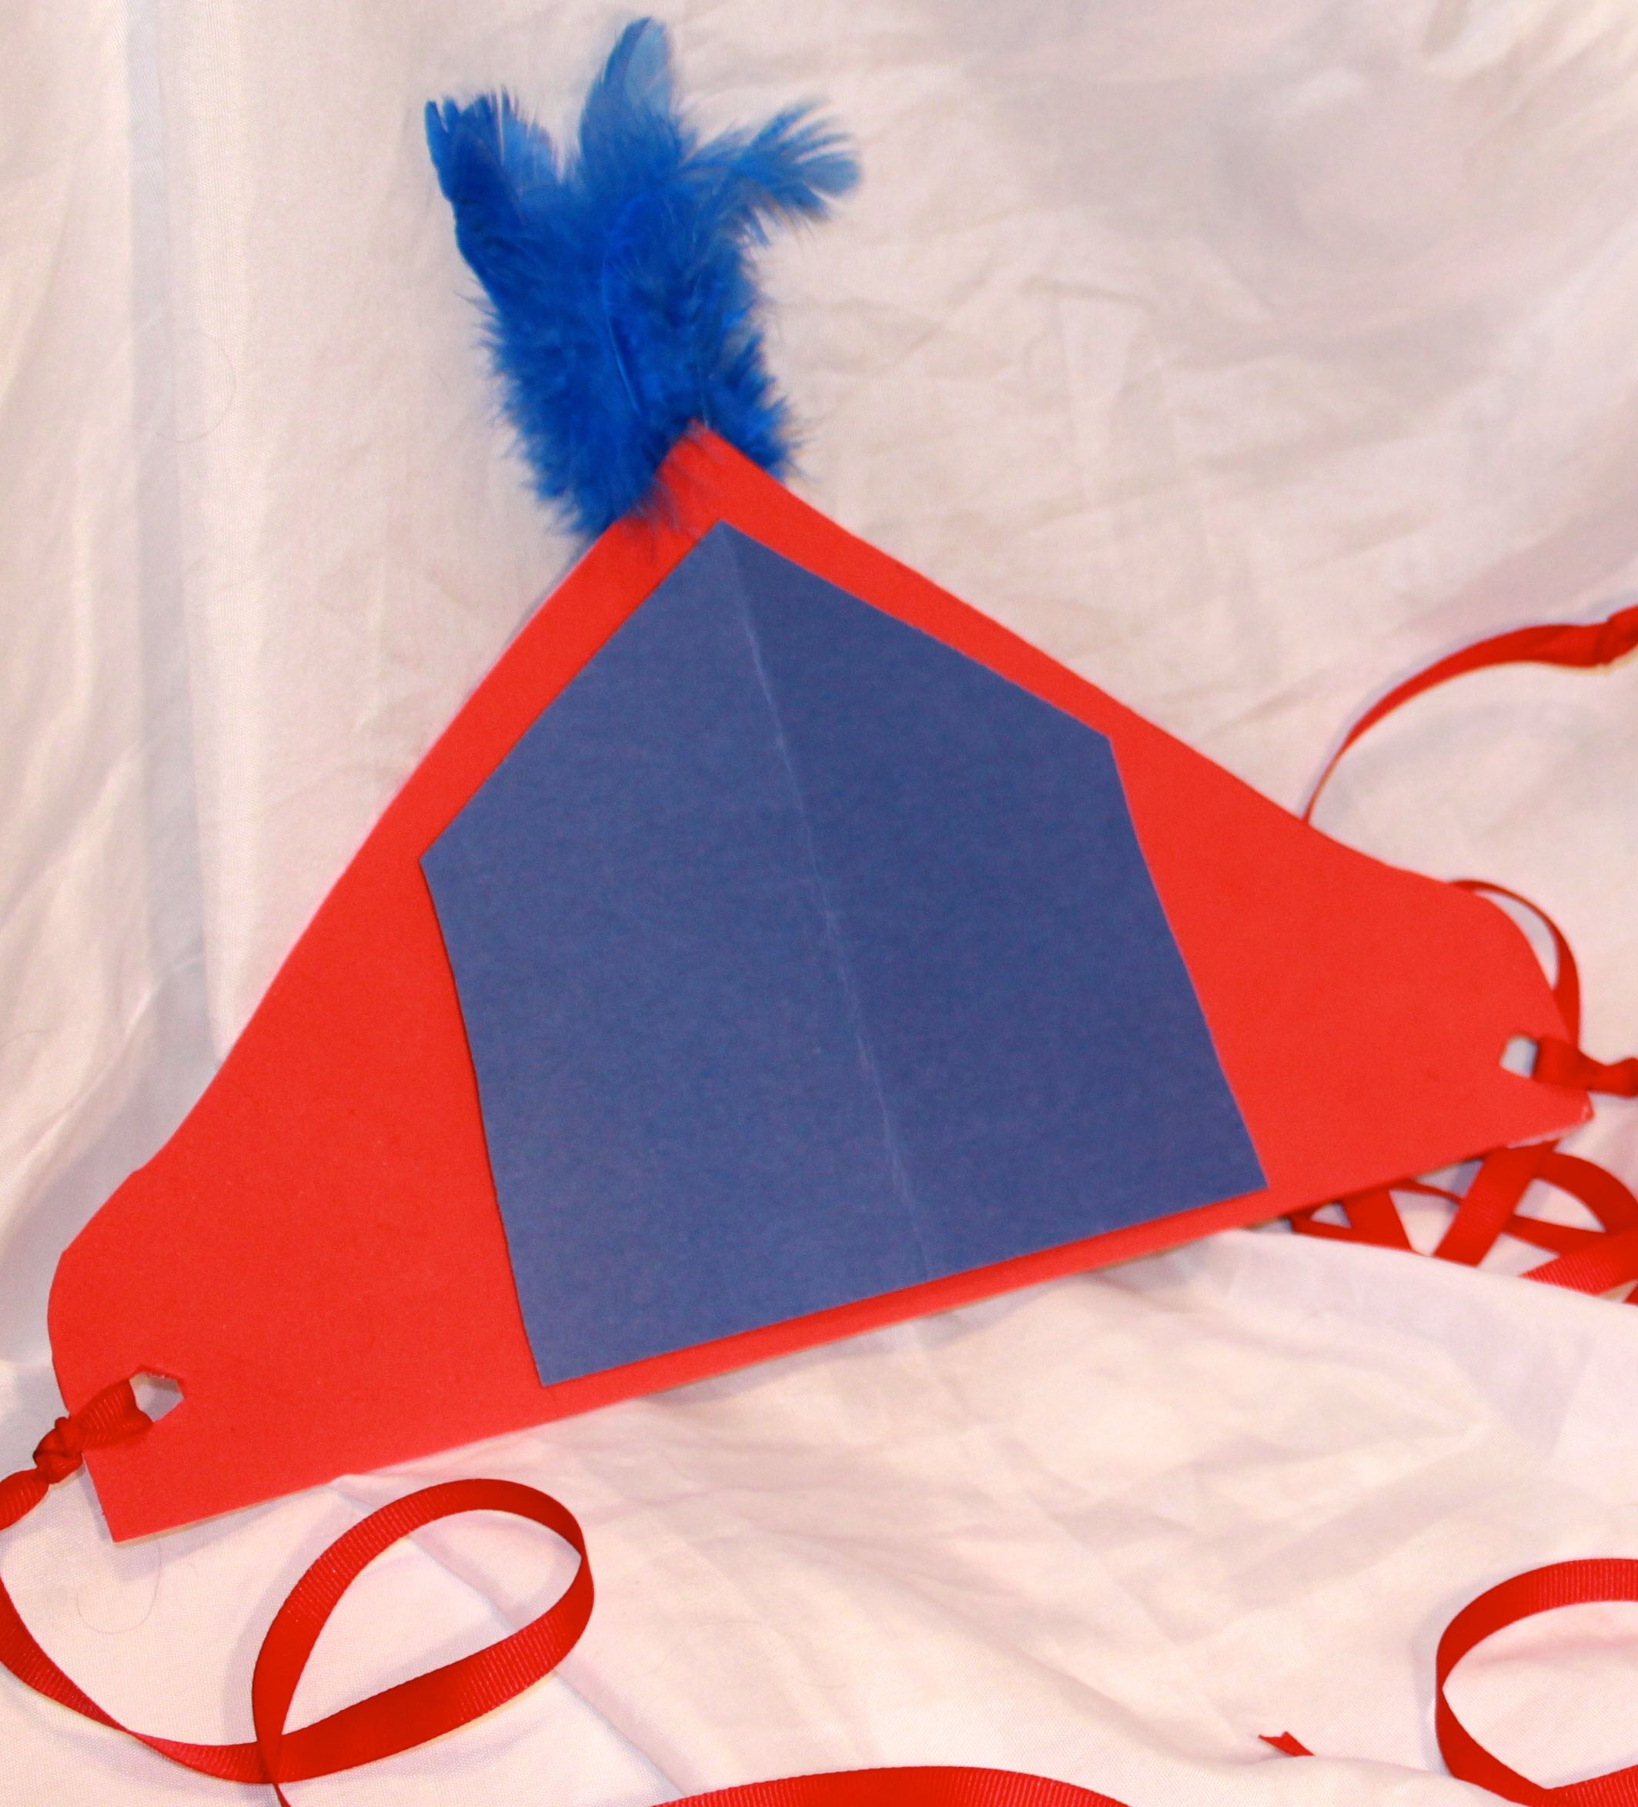

Hats are very popular in Mongolia, and there are many different styles. This headdress is for boys and is similar to those used for special occasions, such as Naadam, the famous Mongolian horse festival.
Here’s what you will need:
- One large piece of red craft foam (12” X 18”)
- A piece of blue construction paper
- Duct tape (red)
- Two pieces of red ribbon, each approximately 12-18 inches long
- Several blue feathers
What to do:
- Cut a 14” pyramid-shaped piece from the red craft foam (see photo for reference). A good method is to fold the craft foam in half before cutting, so that the
- Cut a small opening in each end and tie one length of red ribbon on each side.
- Take the blue piece of construction paper, fold it in half, and cut a pentagon shape that will fit in the center of the foam piece. Using loops of duct tape, place the blue pentagon in the center of the foam piece.
- Turn the headdress over. Gather several blue feathers in a small clump. Tape the ends together with the duct tape, and then secure the feathers to the back of the headdress at the apex.
- Enjoy!

