Diwali: India’s Festival of Lights

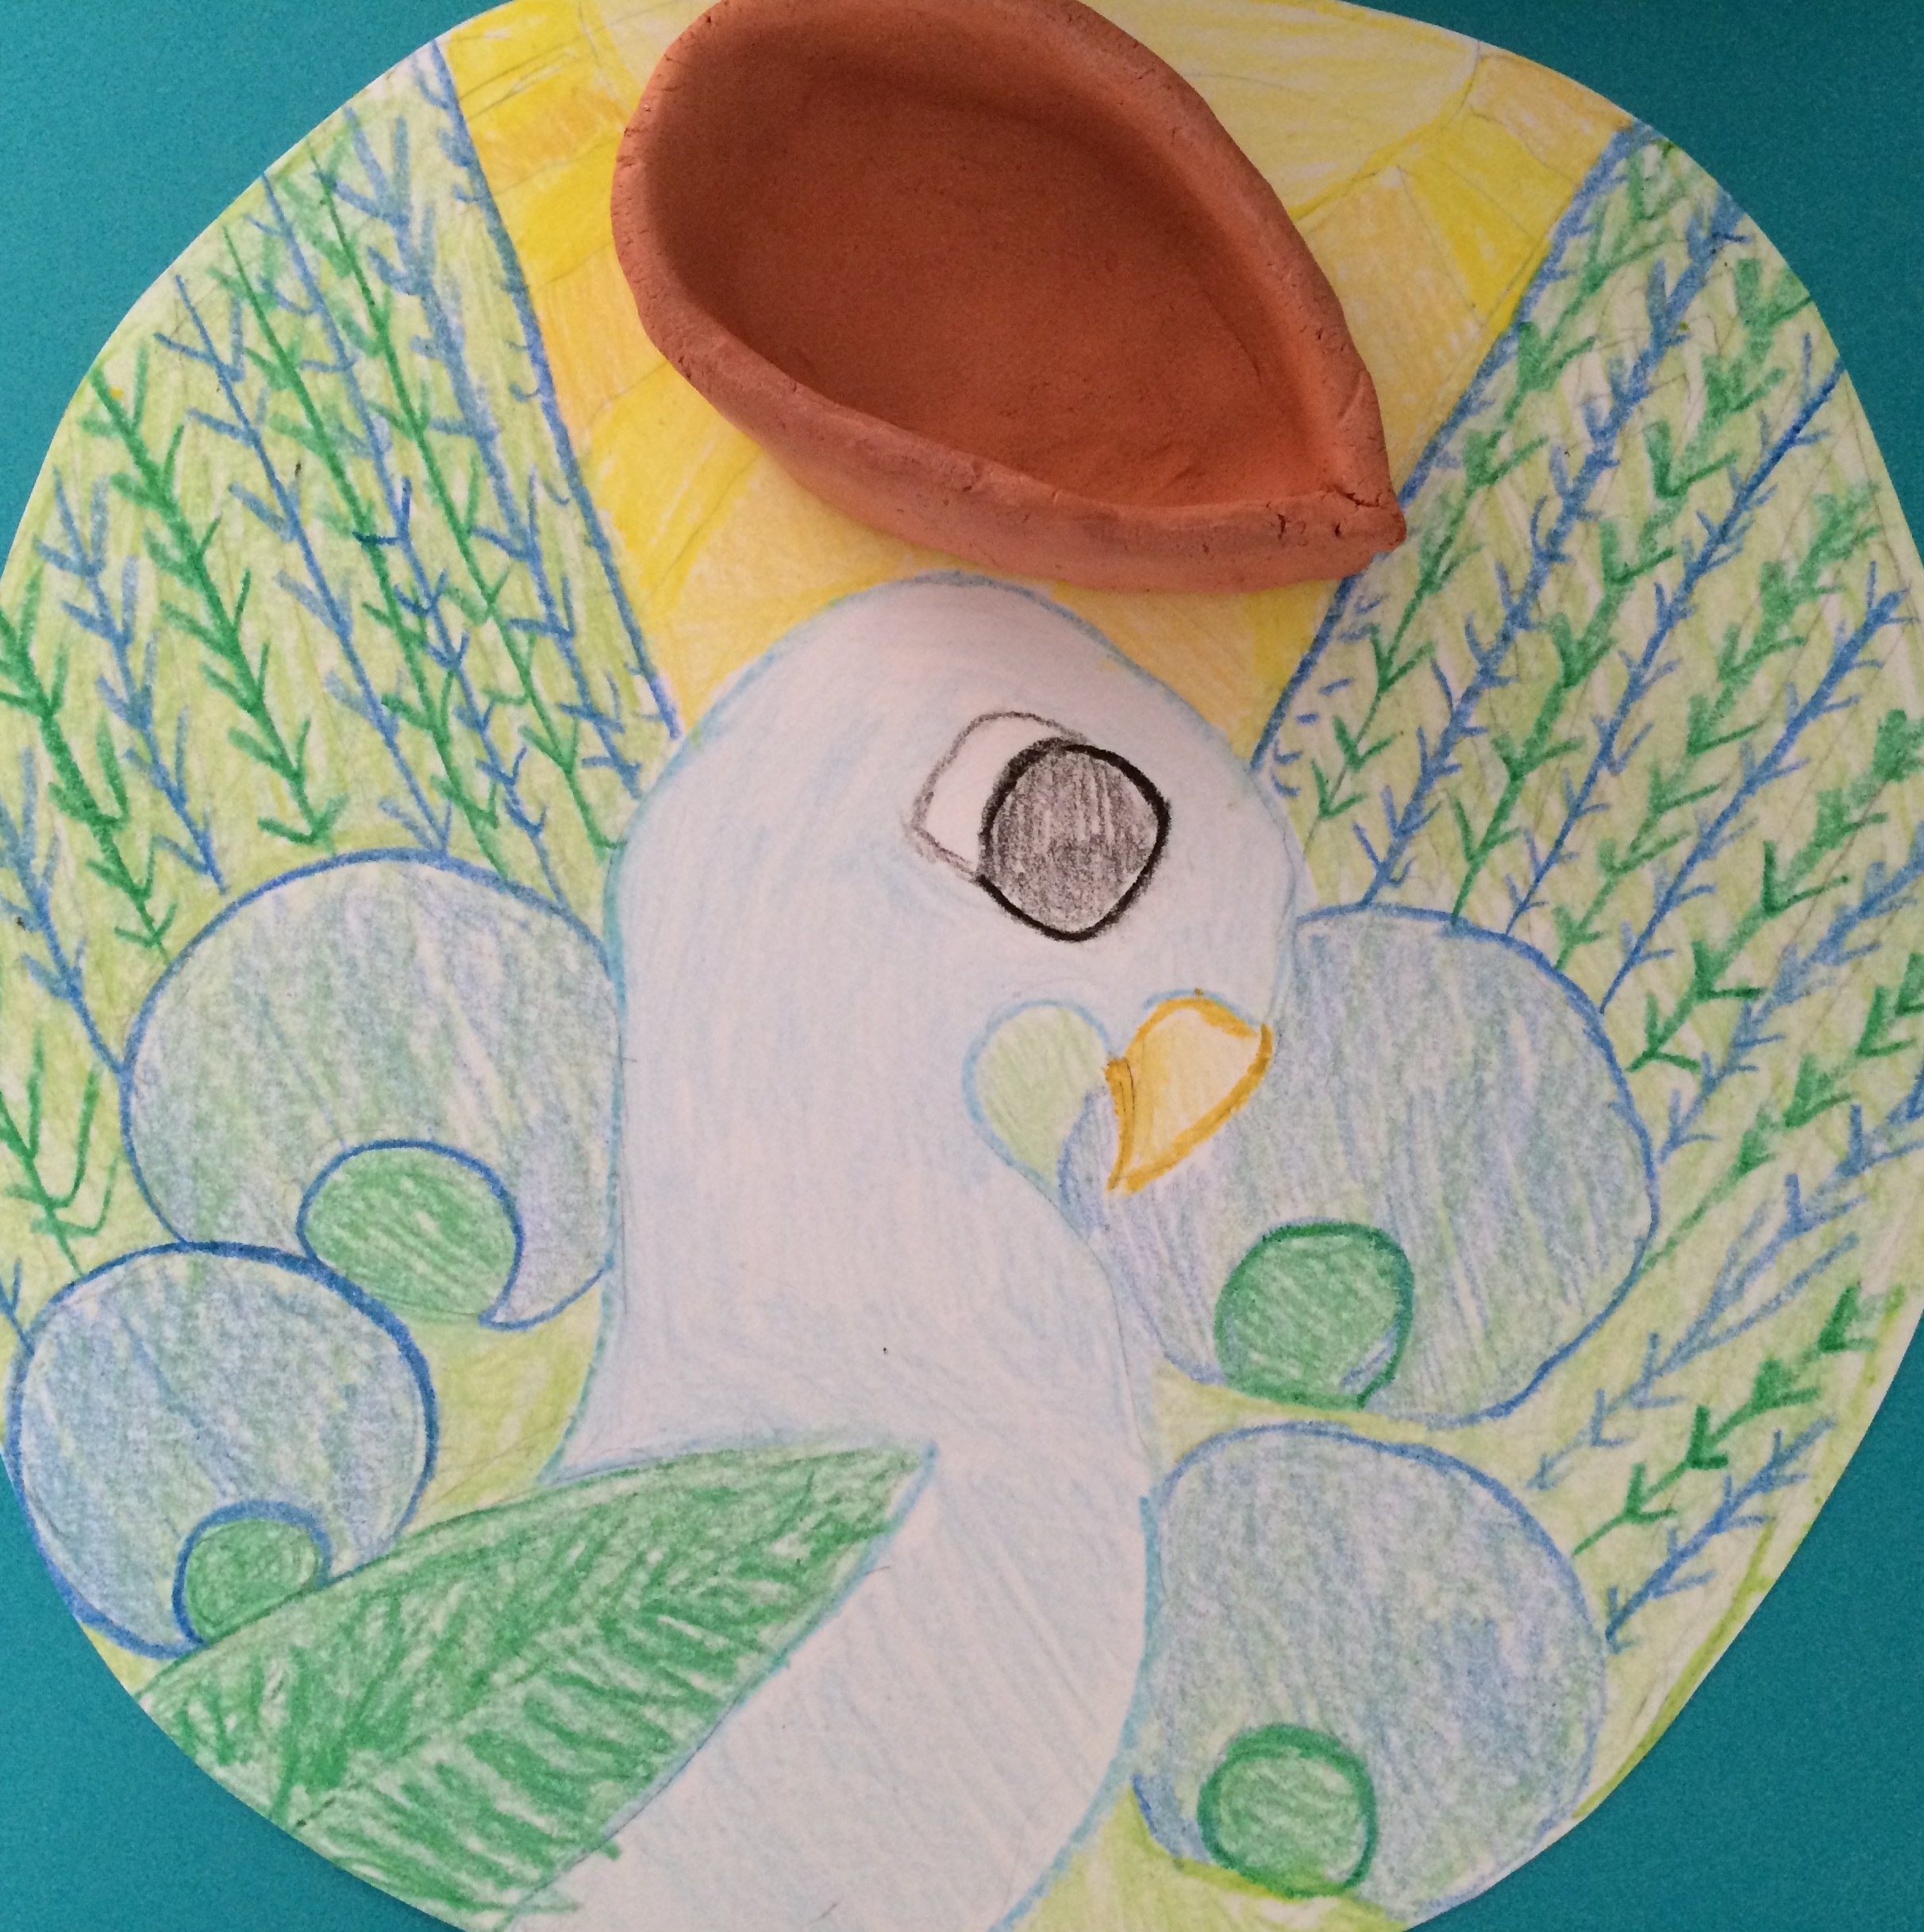

Rangoli Design By Sarah E., Grade 6 (Used With Permission)

Diwali is a festival in India during which people celebrate the triumph of beauty and light over darkness. Every year, Diwali is celebrated in the Fall and began as a harvest festival during which people would worship the goddess Laskhmi and ask for her blessings in the coming year. Although Diwali started as a Hindu festival, it is also celebrated by Buddhists, Jains, and Sikhs, each in their own way. Diwali lasts for five days. On the first day, people clean their homes. On the second day, homes are decorated with clay lamps and designs called rangoli that are created on the floor using colored powders. The third day is the main Festival of Lights that is celebrated with feasts and fireworks. On the fourth and fifth days, families and friends visit one another.

You can celebrate Diwali by creating your own rangoli design and sculpting your own clay lamp.

Here’s what you will need:

- White paper or cardstock
- Crayons or markers
- Terra-cotta colored air-dry clay

Take the white piece of paper and design a bright pattern. It can be geometric, floral, or even depict a peacock. Here are some examples.
You can find these and many others HERE:

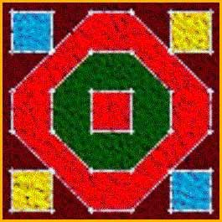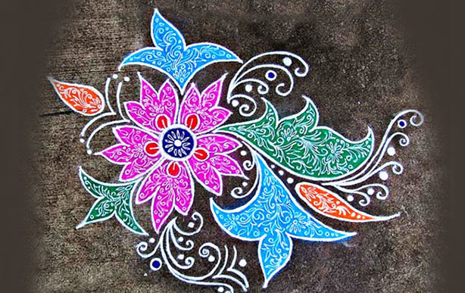
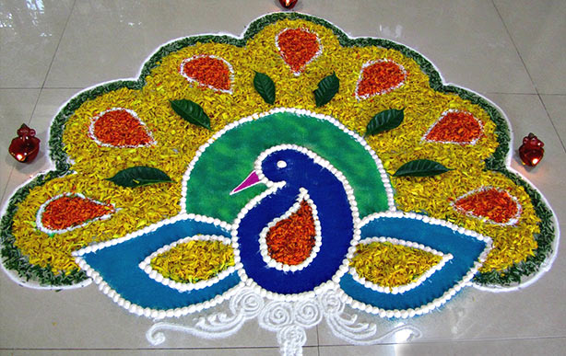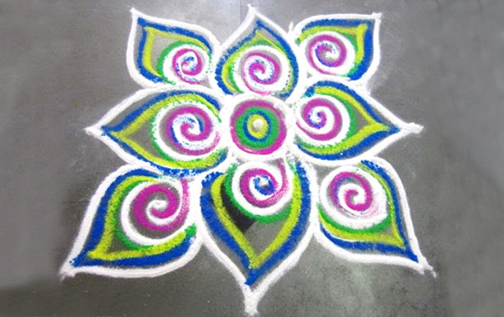

www.diwalifestival.org

