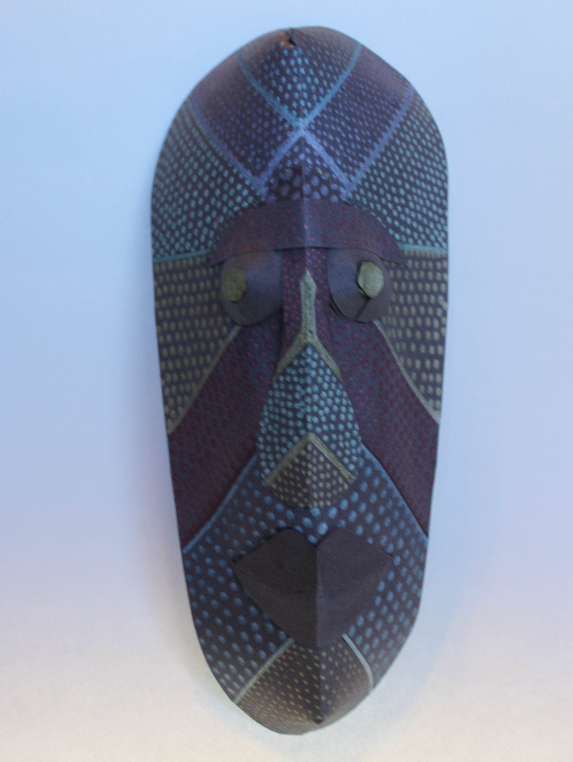

Before I provide the instructions, I need to be clear that I have done quite a bit of research, but I have not been able to determine whether or not there is a history of cultural significance for this type of mask in the Indonesian islands of Bali and Lombok. However, these masks are sold there today, mainly to tourists, so they are popular products created by present-day artisans in Indonesia. To my (very) untrained eye, it seems that these masks show influences from many regional cultures. In any case, this is a fun, 3-D project for kids.

What you will need:

2-3 sheets of black construction paper
gel pens in several colors
scissors
glue
tape

What to do:

- Take one piece of black paper and cut out a large egg shape that is wider on top and slightly narrower on the bottom.
- Make two vertical cuts approximately 1 to 1 1/2 inches long, one in the middle of each end.
- Using the gel pens, make any designs that you like. These can be geometric patterns, or organic elements, like leaves and vines. Use your creativity! Enjoy! Set the mask aside to dry.
- Take another piece of black paper, and cut out two circles for eyes and shapes for the nose and the lips. These are not meant to be realistic. Just create sizes and shapes that seem to fit your mask as a whole. The circles for the eyes should be at least 1 ½ inch in diameter. Set these aside.
- When the mask is dry, fold it vertically in half, connecting the cuts from top to bottom.
- Turn the mask over and at one end, fold the edges of the cut lines inward. Glue the folded pieces together. Holding them together, fold them to one side inside the curved back of the mask and secure with tape.
- Repeat with the other end of the mask.
- Now, your mask should have a nice, round, 3D shape.
- Decorate the facial features as you wish.
- Decide where you want your facial features to be located.
- Carefully glue the mouth to the mask.
- Take the nose and fold it in half vertically. Glue the edges to the mask, letting the middle point of the nose stick out slightly from the face of the mask. For a greater 3-D effect, roll a thin strip of paper into a small cylinder and glue it on the underside of the nose to support the fold in the center of the nose.
- Take the eye circles and make a small cut in each that extends from the edge to the center. Fold the edges of the cut paper inward, glue them together, hold the glued pieces together, fold them to one side, and secure them with small pieces of tape. You should have two small cone shapes.
- Crumple small balls of black paper and glue them inside the cone shapes. Turn them over and gently push down the center point, creating a flat surface on each of the eyes.
- Cut out two small circles that cover the flat parts of the cone shapes. Color the small circles with a gel pen.
- Glue the small, colored circles to the flat areas at the top of each cone. Now you have a pair of nice, 3-D eyes for your mask.
- Glue these pieces to the front of your mask.
- Feel free add any finishing touches you like. I decided to add a decorated piece over the eyes.

I hope you have enjoyed this project. The islands of Bali and Lombok in Indonesia are beautiful places with fascinating and vibrant cultures! Be sure to visit them online!

