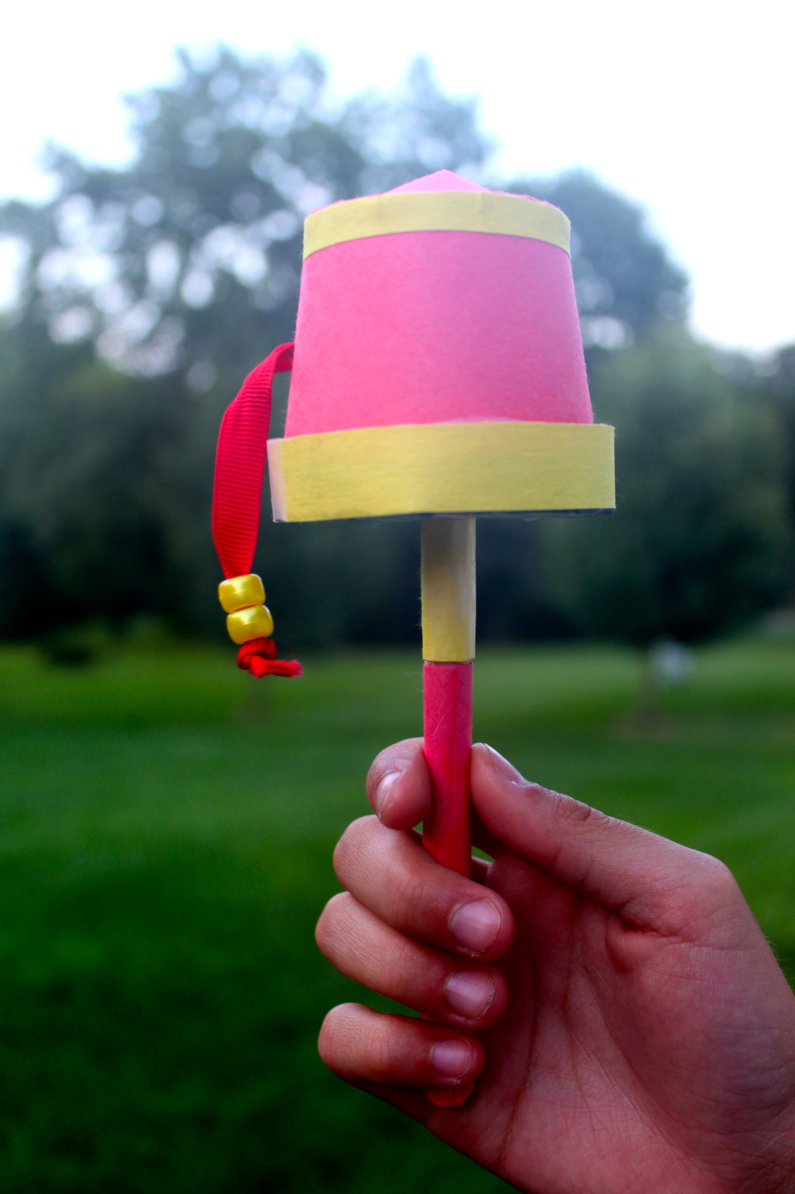

Craft a Tibetan Prayer Wheel

Tibet is known as the Roof of the World because it is home to the world’s tallest mountains, including Mount Everest. It is a spectacular land of beautiful lakes, massive gorges, and alpine grasslands. The people who live in Tibet have a vibrant culture with a long history. Buddhism is an important part of this culture, and has inspired many beautiful art forms. One of these is the Tibetan prayer wheel. These prayer wheels usually contain a mantra, a prayer for kindness and peace, written on a piece of paper. Tibetans believe that prayers can be sent out into the world when the prayer wheel spins.

You can make your own Tibetan wheel for wishes or prayers.

Here’s what you will need:

1 paper cup about 4 inches tall with a lip on the base
1 to 2 pieces of red construction paper
1 piece of yellow construction paper
1 piece of cardstock
1 piece of red ribbon approximately 6 inches long
2 yellow pony beads
1 piece of white paper
1 sharpened pencil
scissors
scotch tape
duct tape
glue

Here’s what to do:

- Take the paper cup and cut it so that it is approximately 2” tall.

- Take the piece of cardstock and trace the bottom of the cup. Then, trace the opening of the cup. Cut out the base-sized circle exactly on the line. Make the large circle about ¼ to ½ inch bigger.

- On the red paper, trace and cut out an additional small circle.

- Using tape, cover the cup with red paper, leaving about ¼ to ½ inch extra paper above and below the cup. Fold the edges under the rim of the cup and over the bottom. Tape them in place.

- Cut the small cardstock circle halfway through, as shown. Fold one corner under the other and tape it in place, making a flat cone the same size as the base of the cup. Place thin loops of tape (duct tape works well) along the edge of the base, just inside the lip. Stick the cone to the base of the cup. Repeat these steps with the small red circle and glue it over the cardstock.

Small Circles

Place thin loops of duct tape inside the lip.
Lip

Bottom of Cup

- Turn the cup over and gently push the sharpened pencil through the base of the cup until it fits in the tip of the cone. Make sure the opening is large enough for the top to spin around the pencil. This is the top of the prayer wheel.

- Using the sharpened pencil or the tip of the scissors, push a small hole through the side of the cup. Thread the ribbon through the hole and tie a knot inside the cup. Slip the two beads over the ribbon on the outside of the cup. Tie a knot in the ribbon to keep them on.

- Take the cardstock and cut a strip about 1 inch wide. This strip should be able to wrap around the larger circle with a small overlap. Fold the strip in half lengthwise. Open it and on one side, make cuts from edge to fold every ½ inch, as shown.
Fold

Wrap the strip of cardstock around the edge of the large circle. Position the edge of the circle on the fold and then fold and tape the cut strips under the circle. This shallow dish is the base of the prayer wheel.

- Cut two strips of yellow paper, one about ¼ inch wide and one about ½ inch wide. Tape (or glue) the thin strip around the top of the prayer wheel. Tape (or glue) the ½ inch strip around the lip on the base of the prayer wheel.

- Cut a small piece of white paper and write a prayer or a wish on it.

- Cut a pencil-sized hole in the center of the base. Make sure the base can spin around the pencil.

- Set the white paper inside the base of the prayer wheel.

- Make thin loops of tape (duct tape works very well here) and arrange them inside the lip on the base of the prayer wheel.

- Gently push the top of the prayer wheel onto the base so that they stick together with the prayer or wish inside.

- Set the prayer wheel on the pencil so that the sharpened tip fits inside the top of the wheel. Notice where the bottom of the wheel falls.

- Cut a strip of yellow paper about 1 inch wide. Wrap it around the pencil just beneath the wheel to create a base on which it can turn. Secure it in place with tape. Cover the rest of the pencil with red construction paper.

- Spin your prayer wheel! (It works best if you hold the prayer wheel straight up. It will take one or two turns to get it spinning smoothly.)

