Craft a Maori Greenstone Pendant

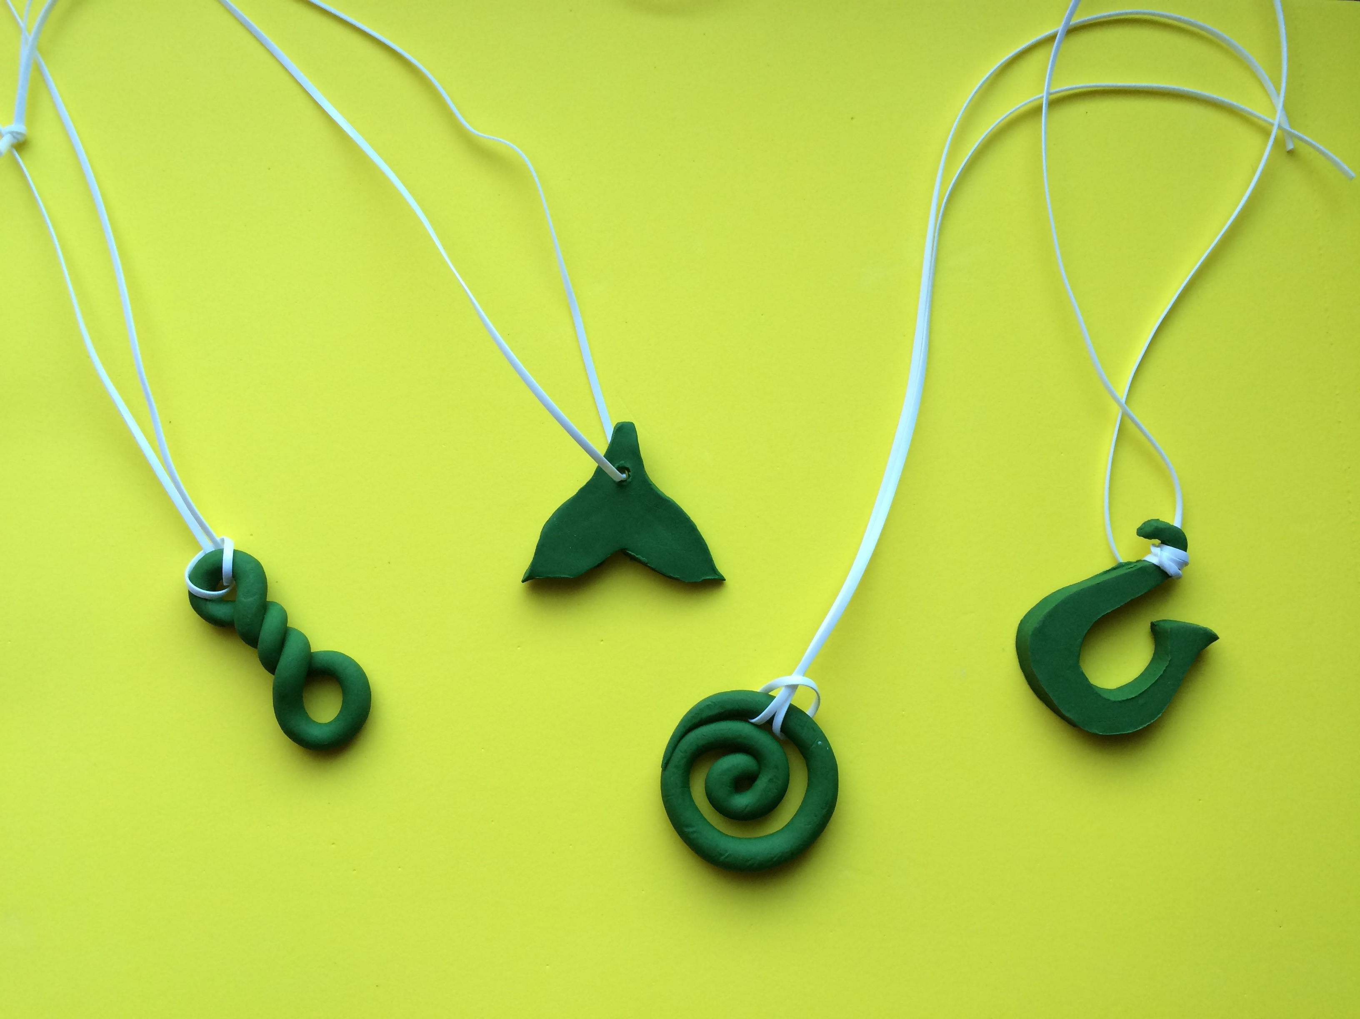
In southern New Zealand, a beautiful, green stone can be found. This stone is known as pounamu in the aboriginal Maori language. Pounamu is often carved into pendants shaped like important symbols in Maori culture. For example, the spiral, known as koru, represents a silver fern frond unfurling and symbolizes new life, hope, and positive change. The whale tail symbolizes speed and strength. The fishhook represents prosperity, abundance, and good health. Twists are also important symbols. A single twist represents loyalty and friendship between two people. A double or triple twist symbolizes bonds between communities and cultures. These pendants are treasured and are often passed down over generations in families. You can craft a Maori pendant, too!
Here’s what you need:
- green polymer clay
- a spool of plastic lanyard

Here’s what to do:
- Open the polymer clay and knead it until soft.
- Break off a piece and create the shape of your choice.
- If you are making the whale tail, poke a hole in the top of the tail.
- Bake the clay according to the package directions.
- Let cool and attach your plastic lanyard.
- ENJOY your new Maori pendant!

