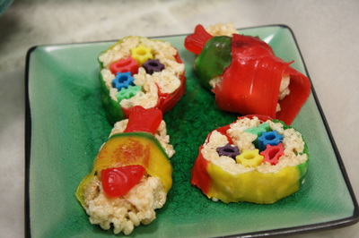

Candy Sushi:

As an island nation with little arable land, Japan has always relied on the bounty of the ocean to meet the nutritional needs of its people. That’s why there are so many delicious seafood dishes that come from Japan. These days, you can find sushi, a dish made with rice and raw fish, in restaurants and markets all over the United States, but kids may be hesitant to try it. This sushi is sure to please, though, because it is made with crisped rice cereal, candy, and fruit roll-ups. My niece, Elizabeth, and I had a great time making these together.
Here’s what you need:
- crisped rice cereal
- butter
- marshmallows
- Swedish fish
- Fruit roll-ups
- licorice in various colors
- waxed paper
Here’s what to do for sushi pieces:
- Prepare crisped rice treats according to the directions on the package.
- Spread the rice mixture in a shallow baking dish (grease first).
- Cut several treats approximately one inch wide and 2 to 3 inches long
- Tear one fruit-roll-up into strips approximately 1/2 to 1 inch wide and 2 to 3 inches long.
- Take the rice treats and set them one Swedish fish on each of them.
- Secure the fish to the cereal treats with the fruit roll-up strips, as shown.
Here’s what to do for sushi rolls:
- Take one whole fruit roll-up, open it up, and roll it out flat.
- Cover the fruit roll-up with a 1/4 to 1/2 inch layer of the crisped rice mixture.
- Cut five pieces of licorice into lengths equal to the shorter sides of the fruit roll-up.
- Place the licorice pieces on top of the fruit roll-up/crisped rice, approximately three inches from one of the short edges.
- Lift one of the short sides of the fruit roll-up and roll it inward around the licorice pieces. Squeeze and compress the cereal mixture as you roll it around the licorice, until you are able to close the fruit roll-up on the outside.
- Roll the sushi roll between your hands to create a round, relatively even shape, as shown.
- Place the roll on its side and carefully slice off segments that are approximately 1/2 inch long
- Enjoy your sushi!
